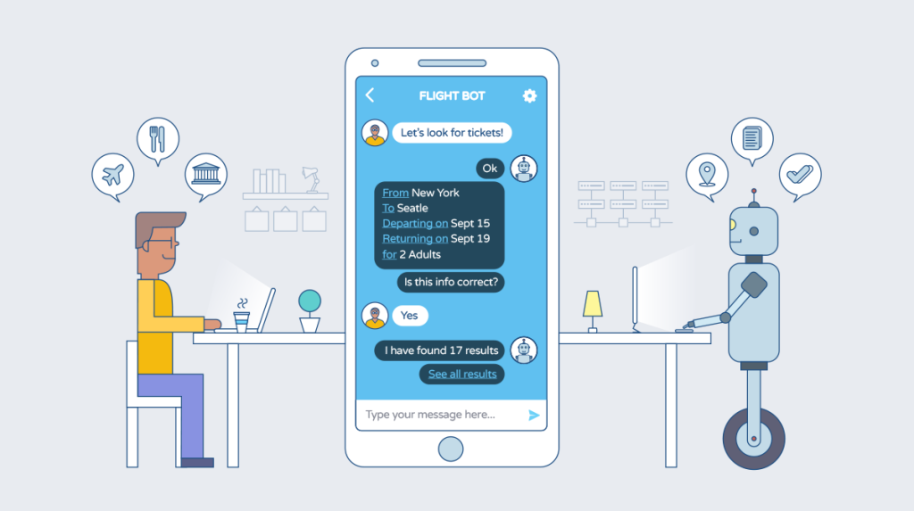

CHAT BOTS

Research

# **Introduction**

Chats Bots are computerized communication’s systems that work on a user interaction and converses through sound or pictorial methodology(text-based), they provide an environment of extracting information from a customer and have transformed as well as revolutionized the World of Business in so many ways. These programs run completely on Artificial Intelligence and they have been used to reduce customer clicks and enhance transaction speeds as stated by Soni et al(2016).

**What Are Chat Bots**

As mentioned above, Chat Bots are computerized, automated systems that converse directly with the user through audio or textual methodology. Pilato et al mentions that. Chat Bots are the easiest way of establishing a dialogue system that utilizes what he calls pattern matching based rules to form a sound interaction.

**BENEFITS OF CHAT BOTS**

**TYPES OF CHATBOTS**

**MENU BASED CHATBOTS**

The most common and simplest type of chatbots on the market today are menu-based chatbots, which take the shape of buttons and top-down menus. These chatbots work on the notion of decision trees, which need you to make choices to acquire conclusive responses. It is recommended that the user make these decisions by selecting their alternatives and drilling down into the AI's appropriate response.

**Keyword Recognition-Based Chatbot**

This form of chatbot is a little more advanced; it aims to listen to what the user types and respond correctly based on keywords derived from customer answers. This bot blends customisable key phrases with artificial intelligence to provide consumers with an effective response. Unfortunately, these chatbots fail when faced with recurrent keyword usage or duplicate requests.

**THE FUTURE OF CHATBOTS**

Voice chatbots, which have already garnered a lot of traction, are the next big thing in industries including payments, health, commerce, and marketing. Because they do not rely only on the most basic means of human communication (speech/voice), voice chatbots are regarded to be more natural and effective. It can, however, have a more integrated user interface with direct voice input, allowing it to do more.

Employees benefit from chat bots because they make HR much more accessible. They're can deliver accurate and timely information replies to frequently asked questions 'The' more complicated queries are possible human intervention is automatically increased review and reaction.

**RECOMMENDATIONS**

**REFERENCES**

Adamopoulou, E. and Moussiades, L., 2020, June. An overview of chatbot technology. In *IFIP International Conference on Artificial Intelligence Applications and Innovations* (pp. 373-383). Springer, Cham.

Carlander-Reuterfelt, D., Carrera, Á., Iglesias, C.A., Araque, Ó., Rada, J.F.S. and Muñoz, S., 2020. JAICOB: A data science chatbot. *IEEE Access*, *8*, pp.180672-180680.

Samuel, I., Ogunkeye, F.A., Olajube, A. and Awelewa, A., 2020, November. Development of a Voice Chatbot for Payment Using Amazon Lex Service with Eyowo as the Payment Platform. In *2020 International Conference on Decision Aid Sciences and Application (DASA)* (pp. 104-108). IEEE.

Smutny, P. and Schreiberova, P., 2020. Chatbots for learning: A review of educational chatbots for the Facebook Messenger. *Computers & Education*, *151*, p.103862.

Waghmare, C., 2019. Deploy chatbots in your business. In *Introducing Azure Bot Service* (pp. 31-60). Apress, Berkeley, CA.

Wu, E.H.K., Lin, C.H., Ou, Y.Y., Liu, C.Z., Wang, W.K. and Chao, C.Y., 2020. Advantages and Constraints of a Hybrid Model K-12 E-Learning Assistant Chatbot. *IEEE Access*, *8*, pp.77788-77801

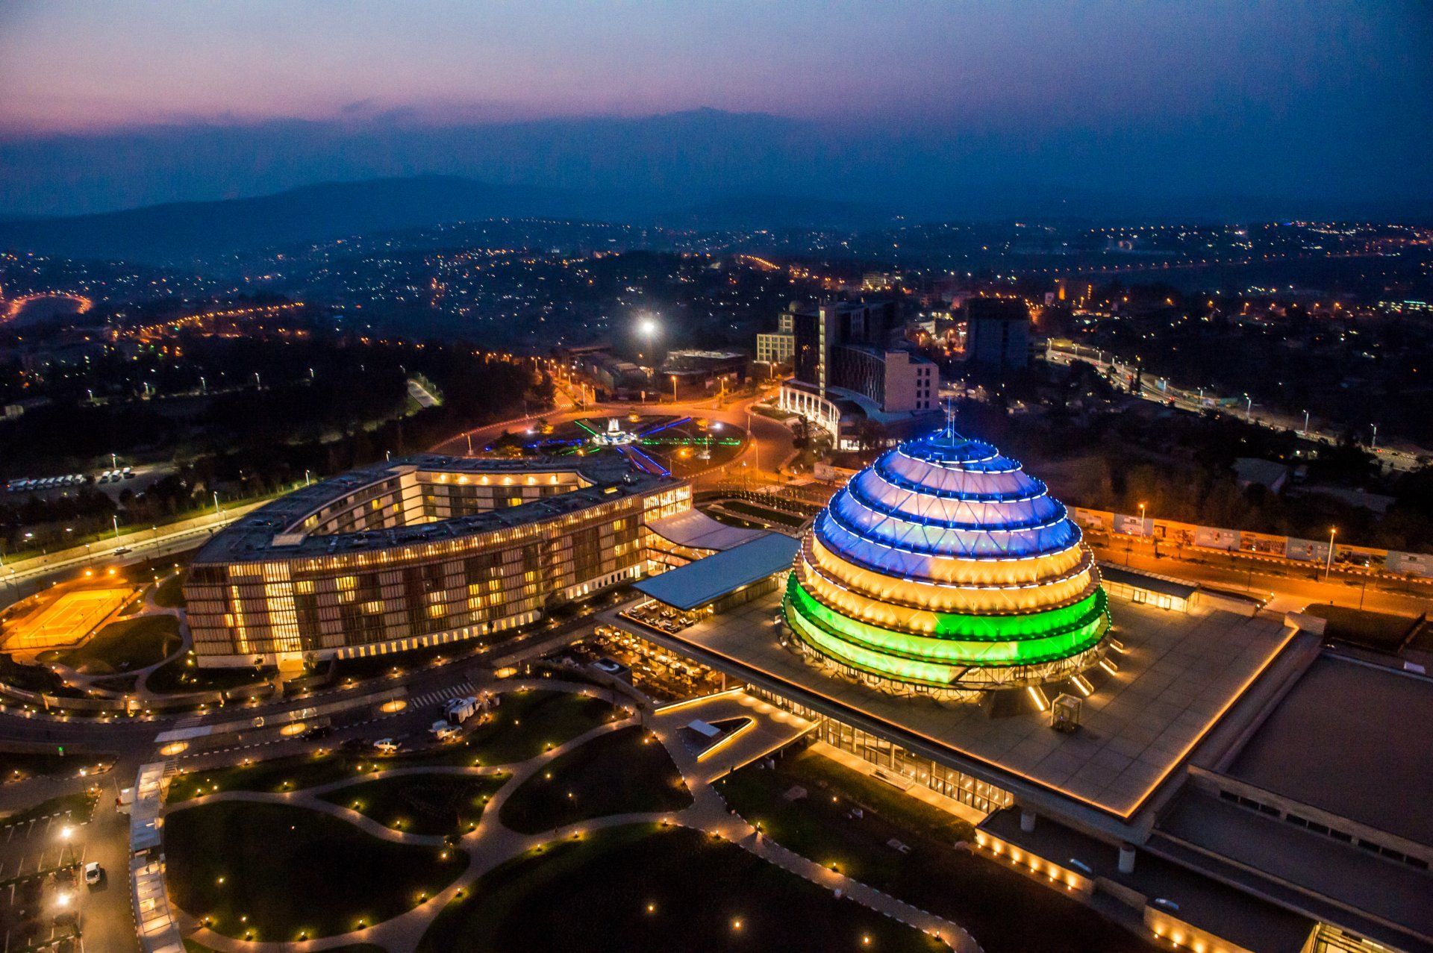FGGFGFFGHH

BY: FBDA20-046

Website Development on

KIGALI

The City Of Cleanness and Security

**INFORMATION STRUCTURE**

**Name of Website**

Kigali

**Purpose**

The website will act as an informative portal that will educate tourists and enthusiasts on the beauty of the City of Rwanda KIGALI.

The website will include of the following.

* **Home/Index Page**: It will have a brief description of what the City Holds for the user as well as what to expect as one explores the website. The page will harbour hyperlinks that redirect the user to the other pages and resources pertaining to Kigali.
* **About:** This page is to have a further elaboration on information regarding the city, it will answer the WHO, WHY, WHEN, HOW, WHERE and WHICH questions. It will include of information that explains *when the City was founded, who founded the city, who lives in the city, where is the city, how many people live in the city and how it came to be the capital city of Rwanda. The main aim is to include facts and foundations that will not bore the user but educate and entertain thus explaining why it must be* ***edutaining****.*
* **Lifestyle:** This page is more ideal to the people interested in visiting the city for relaxation or a vacation, the page is to include of content that lures the user and ignites the zeal to visit the city. It will include of tourist attraction sites, hotels, schools, recreation centres, culture/way of life of the people in Kigali. It should have graphical content that visualises the expectation for the user.
* **Events:** The programs in the city , activities set to take place in the city will be displayed here and information about those events will also be included here to enable the user to show interest.
* **Connect/Contact:** It will be the page that harbours contact information of how the user can receive notifications(weekly) on the events or activities that will be happening in the city. This page will also harbour a form with the following details: 1. Full names, Country and Region and Email. After the forms has been filled the user will be redirected to the Acknowledgement of Subscription page (Thank You.Html).

**SITE MAP**

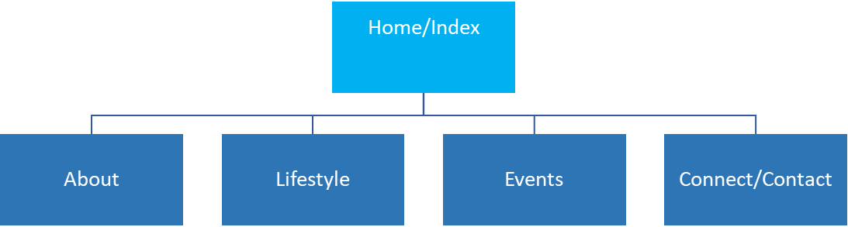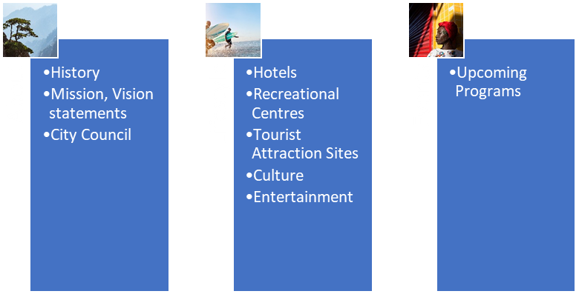

Connect

Subscribe To Newsletter

**Website Framework**

**PAGE TEMPLATES**

